Table of Contents
Practice Exercise #1 2
Practice Exercise #1B 5
Practice Exercise #1 – Deeper Dive 8
Practice Exercise #2 11
Practice Exercise #2B 15
Practice Exercise #2 – Deeper Dive 18
Practice Exercise #3 23
Practice Exercise #3B 26
Practice Exercise #3 – Deeper Dive 28

Practice Exercise #1
PRACTICE EXERCISE #1 SOLUTION (USING NEW MEXICO)

You are preparing for a statewide meeting with your CSBG entities and would like to present a graph showing your state’s progress toward meeting organizational standards in FY 2020. Using CSBG Quick Facts, how would you generate this report?
Step 1:  Once in the Data Warehouse, select the CSBG Quick Facts icon. | 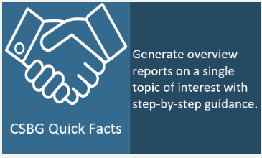
Step 2:  Once in Quick Facts, select Single State Reports (since we are only interested in looking at one state). | 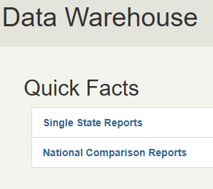
Step 3:  In the Single State Reports screen, select “What percentage of CSBG eligible entities are meeting Organizational Standards?” | 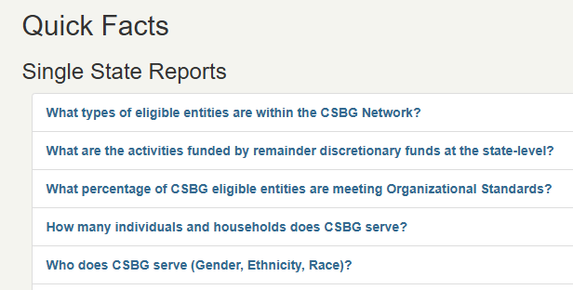
Step 4:  On the State Selection screen, select your state. (New Mexico is used as an example for this exercise solution). Then, select Next. | 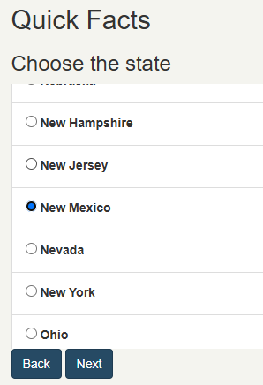
Step 5:  On the Year selection screen, select “2020.” Then, select Next. | 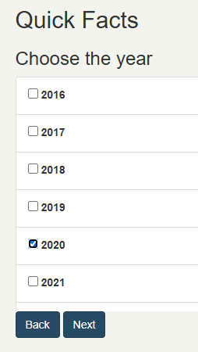
Step 6:  You are done! | 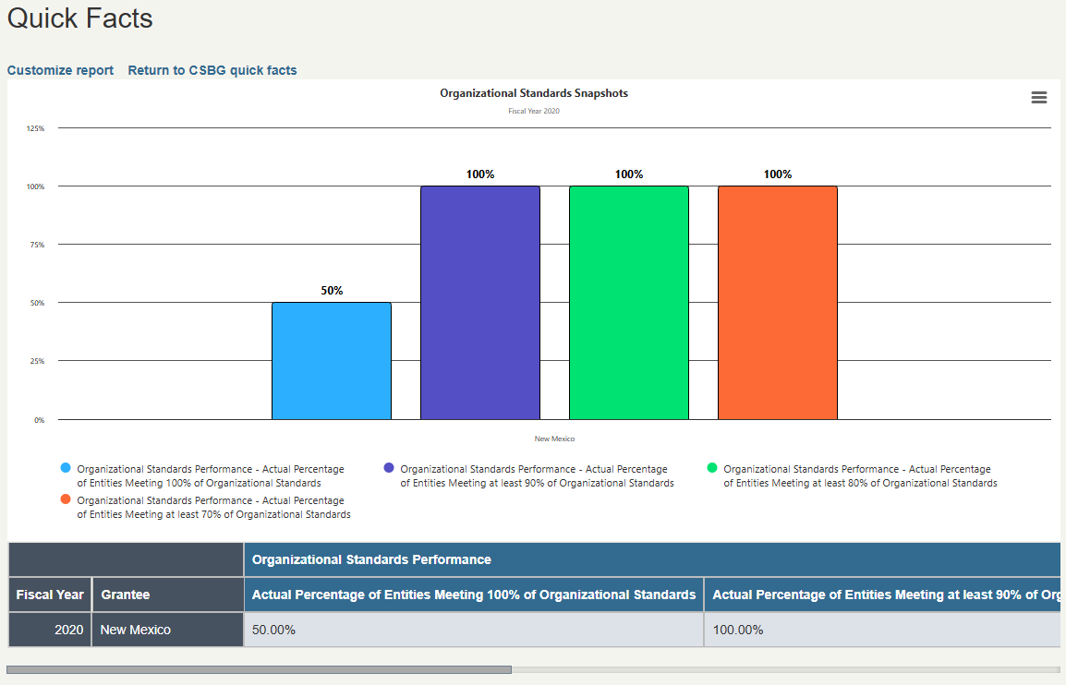

Practice Exercise #1B
PRACTICE EXERCISE #1B SOLUTION

To provide more context, you decide to look at your state’s progress toward meeting Organizational Standards over time. Using the customize option at the top of the report screen, how would you revise your existing report (above) to add in FY 2019 data?
Step 1:

Starting on the results page from the previous example, click “Customize report” at the top of the page.
Step 2:  In the first section of the customize screen, some criteria will already be selected from our previous report—including the year (2020), the geography (State Data) and state. Click on “2019” to add that additional data to the report. | 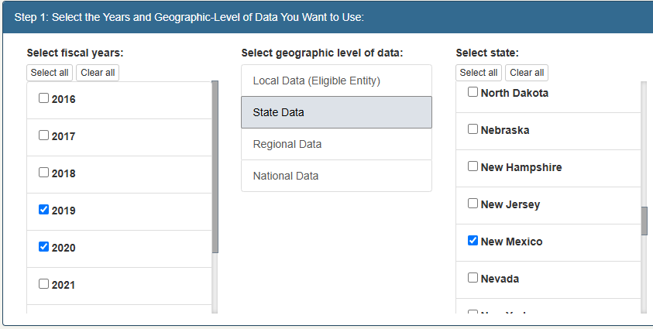
Step 3:  In the second section of the customize screen, our selections from the previous report remain. We do not need to make any changes here. | 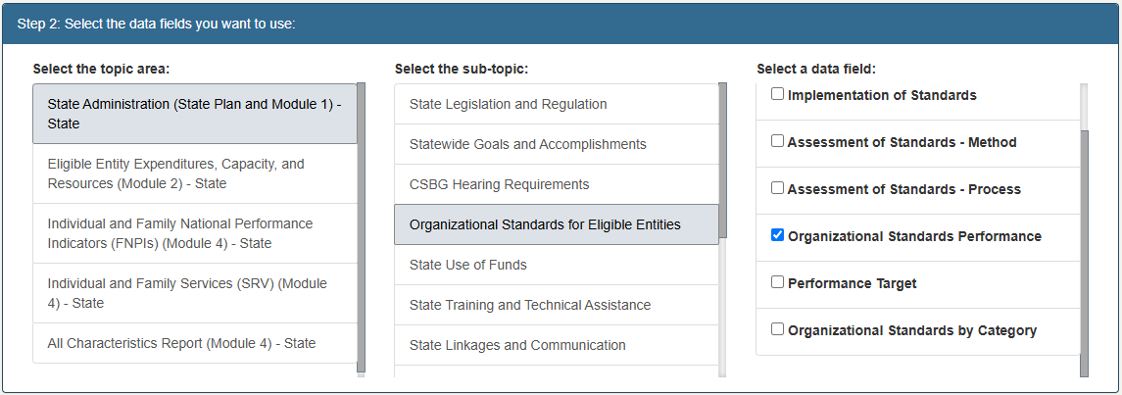
Step 4:  In the last section, we want to make sure that “Bar graph” remains selected as the option for displaying the data. | 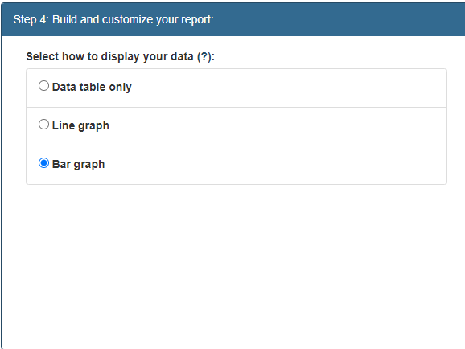
Step 5:  Under “Add a title, subtitle, and description,” we will update our sub-title. Once complete, click “Create Data Report.” | 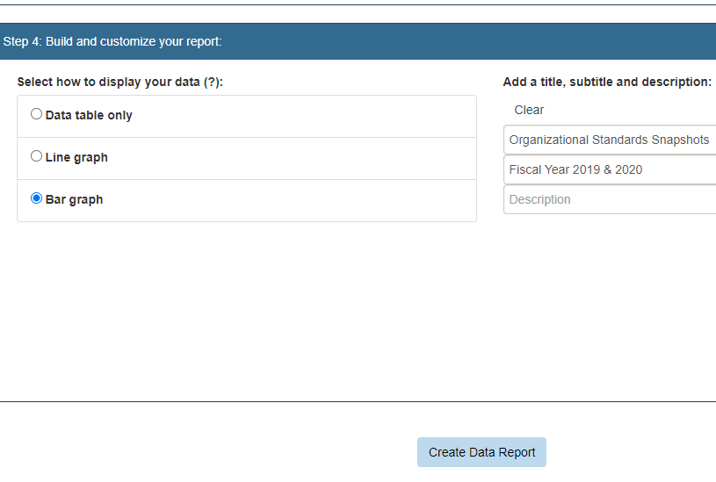
Step 7:  You are done! | 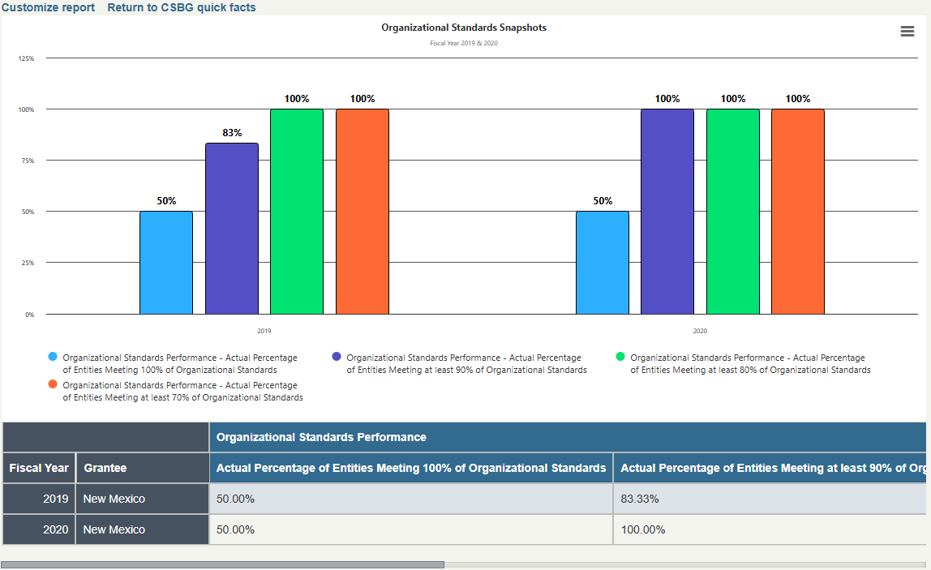

Practice Exercise #1 – Deeper Dive
PRACTICE EXERCISE DEEPER DIVE SOLUTION

You decide it would be valuable to show entities how your state’s progress in meeting CSBG Organizational Standards compares to national progress. How would you add national data to your existing graph/table using the “customize” option at the top of the report screen?
Step 1:

Starting on the results page from the previous example, click “Customize report” at the top of the page.
Step 2:  In the first section of the customize screen, some criteria will already be selected from our previous report—including the years (2019 and 2020), the geography (State Data) and state. Click on “National Data” and “UNITED STATES” to add national data to the report.  We do not need to make any change to Step 2 and Step 3. | 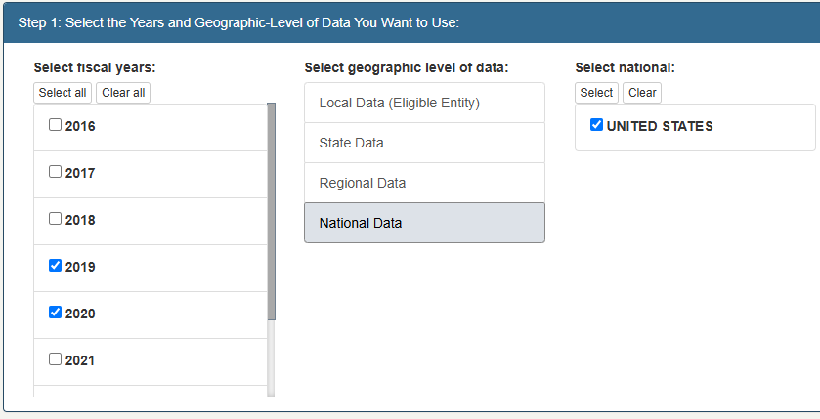
Step 3:

In the last section, we want to make sure that “Bar graph” remains selected as the option for displaying the data.
Step 4:  Under “Add a title, subtitle, and description,” we can update our report title to say “Organizational Standards Snapshots – National Comparison”. Then, we can select “Create Data Report.” | 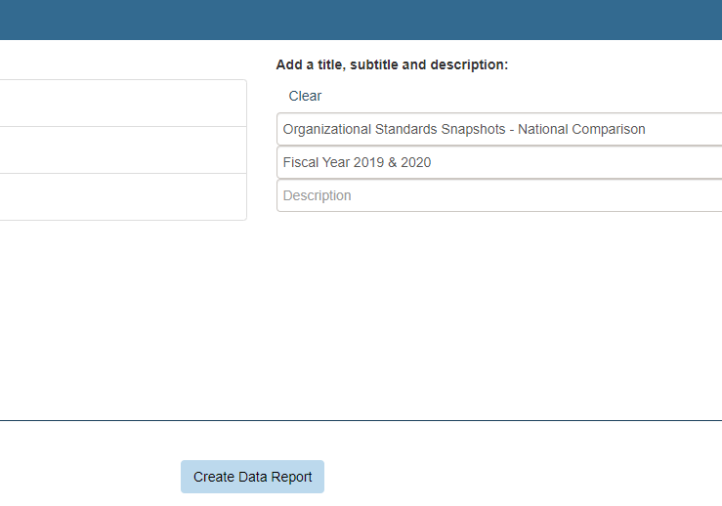
Step 5:  You are done! | 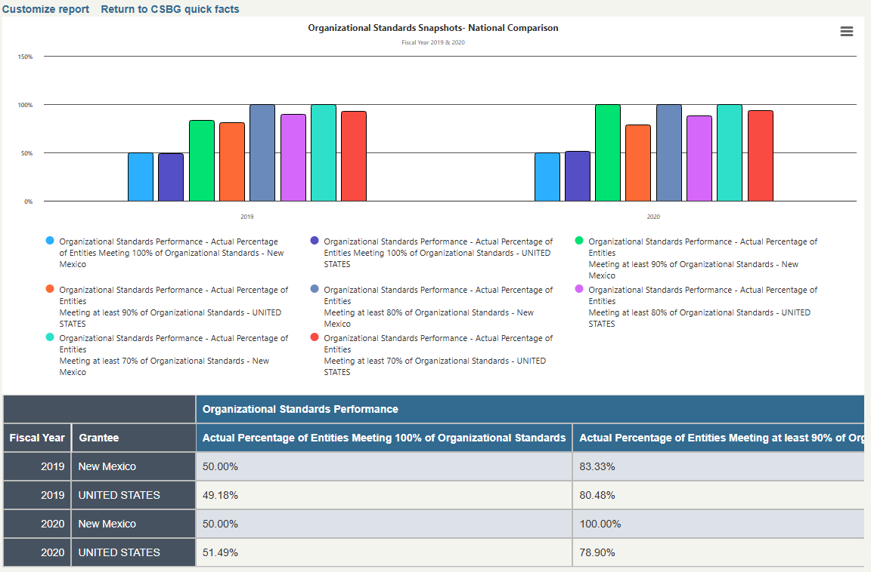

Practice Exercise #2
PRACTICE EXERCISE #2 SOLUTION (USING ARKANSAS)

Your state agency leadership has asked you to produce a report that displays the total amount of funds expended by each CSBG entity in FY 2019. Using the Advanced Data and Analytics Option, how would you generate this report?
Step 1:  Once in the Data Warehouse, select the Advanced Data and Analytics option. | 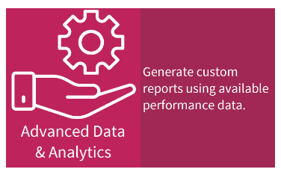
Step 2:  In the Advanced Data and Analytics screen, select “2019” (since we are only interested in data from that year).  Then select “State Data” under “Select geographic level of data” and select your state. (Arkansas is used as an example for this exercise). | 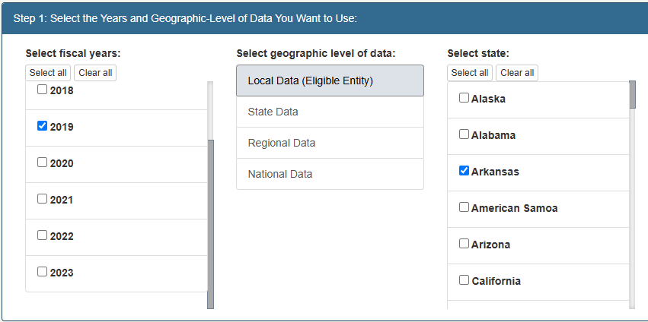
Step 3:  In the second section, click “Eligible Entity Expenditures, Capacity, and Resources (Module 2) – Eligible Entity.”  Then select “Expenditures.”  In the “Data Field” section of the report, select “CSBG Expenditure Domains (By Entity).”  We will not have to make any changes in Step 3. | 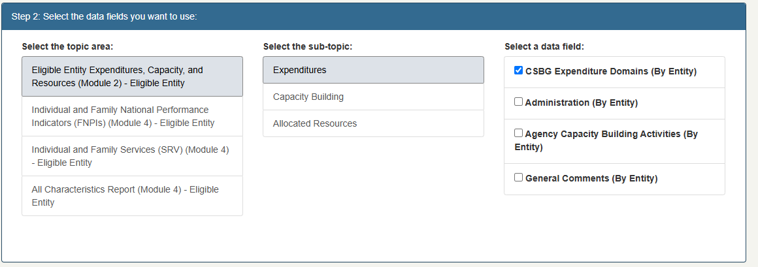
Step 5:  In the Step 4, select “Data table only.”  Since there are a large number of categories, we will not make a graph. | 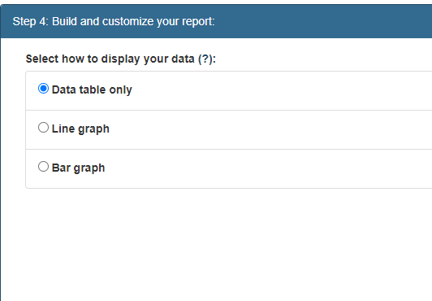
Step 6:  Name the report “Entity-Level Expenditures” with the subtitle “Fiscal Year 2019.” Once complete we can select “Create Data Report.” | 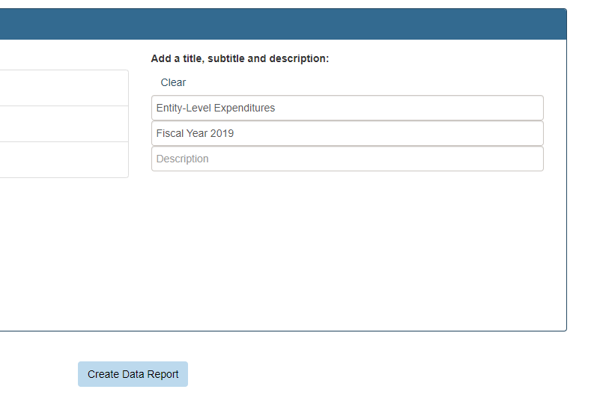
Step 7:  You are done! | 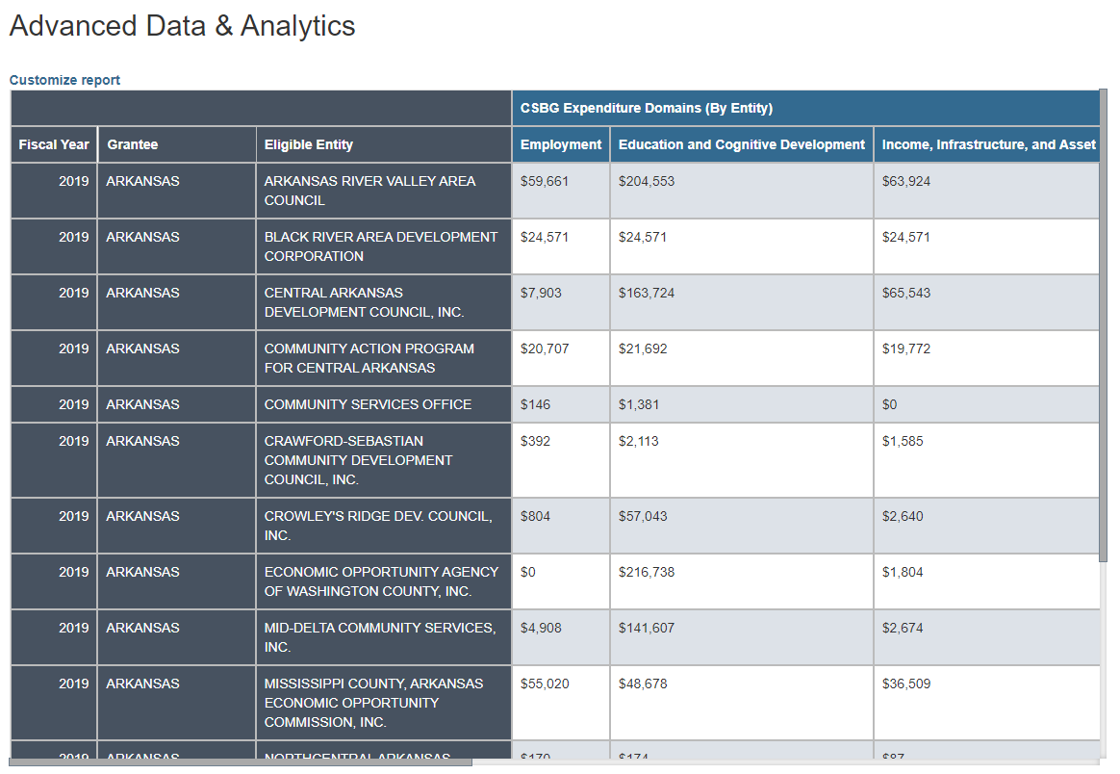

Practice Exercise #2B
PRACTICE EXERCISE #2B SOLUTION

Your agency director follows up and asks you to also provide the amount of funds spent by each CSBG entity in your state for administrative purposes. Using the customize option at the top of the report screen, how would you add FY 2019 administrative spending for each entity to your existing graph/table?
Step 1:

Starting on the results page from the previous example, click “Customize report” at the top of the page.
Step 2:  In the first section of the customize screen, the criteria from our previous report will already be selected.  We will make no changes to this section. | 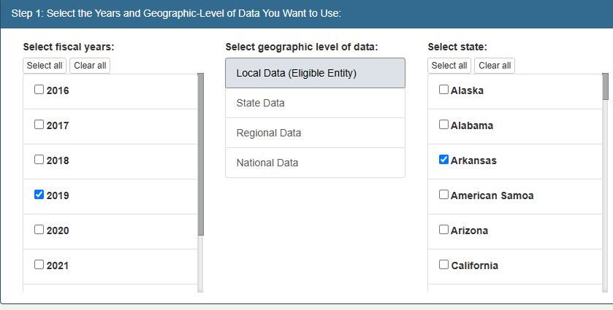

Step 3:  In the second section of the customize screen, “Eligible Entity Expenditures, Capacity, and Resources (Module 2) – Eligible Entity,” “Expenditures,” and “CSBG Expenditure Domains (By Entity)” should be still be selected. Do not make any changes to these.  Select “Administration (By Entity)” as a sub-topic in addition to “Expenditure Domains.”  We will not have to make any changes to Step 3. | 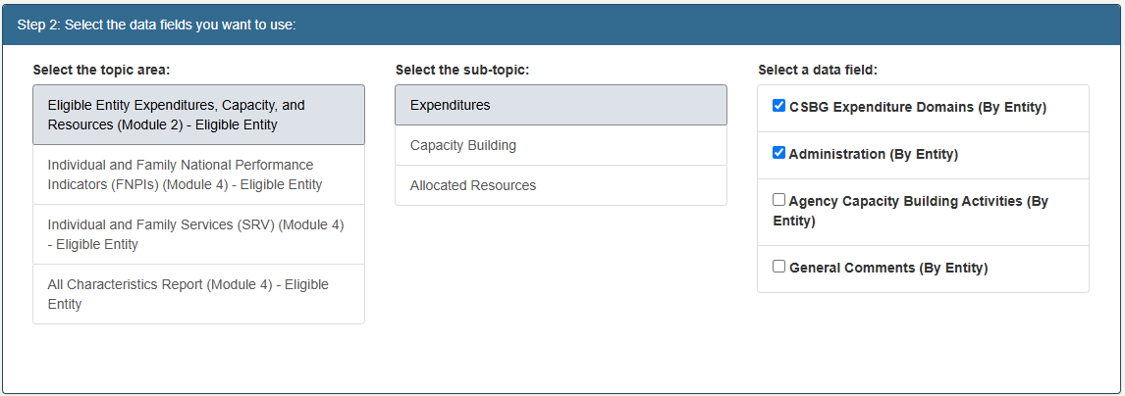
Step 4:  In the last section of the menu, leave the selection for “Data table only.”  Rename the report “Entity-Level Expenditures and Administrative Costs” to reflect the changes made. Once that is complete, we can click “Create Data Report.” | 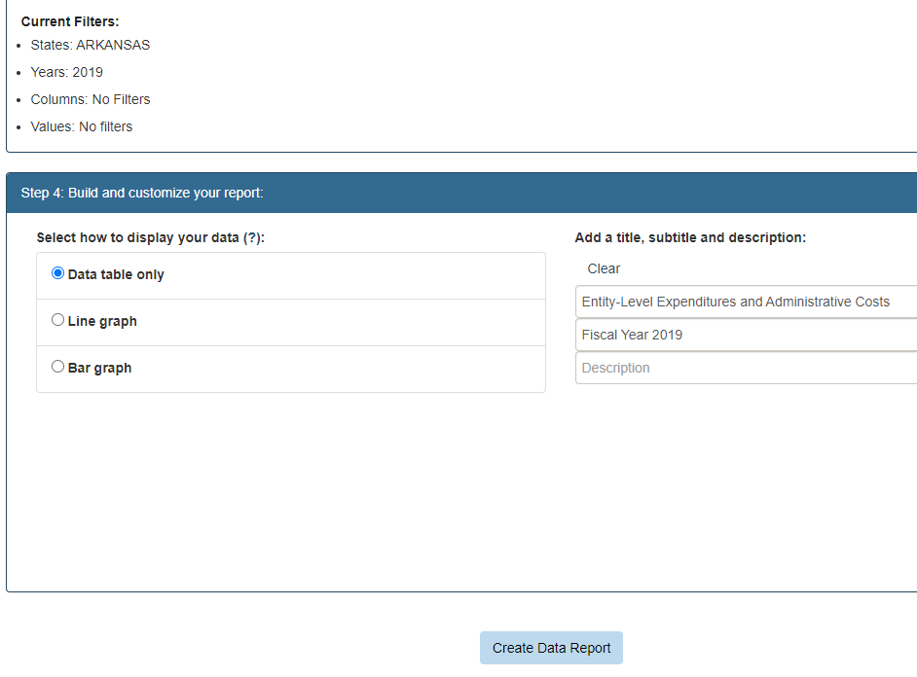
Step 6:  You can see the additional data field we added by scrolling all the way to the right.  You are done! | 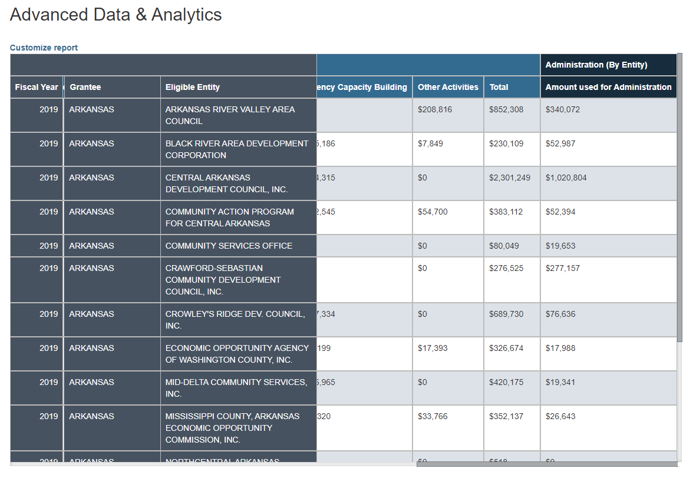

Practice Exercise #2 – Deeper Dive
PRACTICE EXERCISE DEEPER DIVE SOLUTION

Your agency director looks over the report you’ve generated, comparing CSBG administrative spending with overall CSBG spending for each entity in FY 2019. They are particularly interested in the proportion of funding each agency spent on administrative costs. They ask if you can further modify the existing report to create a bar graph of the total spending and administrative spending for each entity. How would you do this?
Step 1:  Starting on the results page from the previous example, click “Customize report” at the top of the page. | 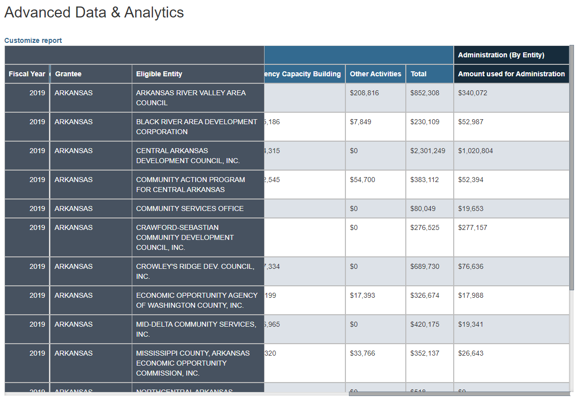
Step 2:  Leave all the selections in the first two sections as they are. | 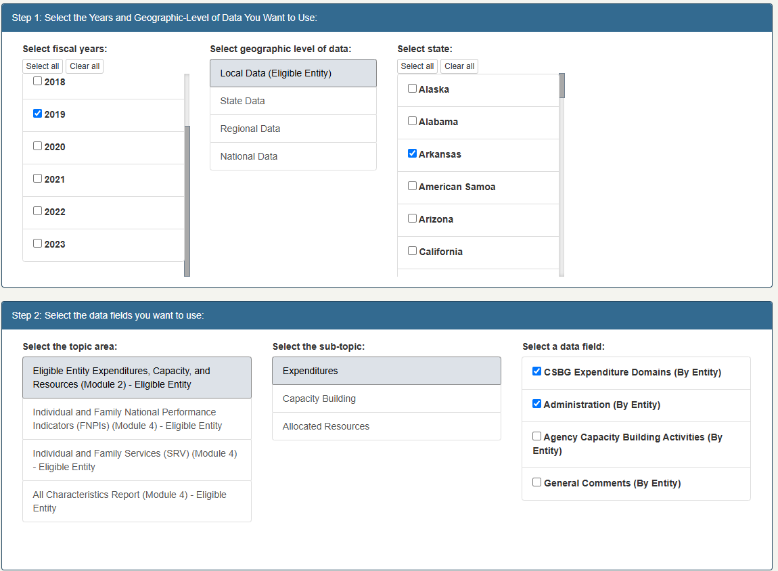

Step 3:  In the Step 3, select “Set filter” on the “CSBG Expenditure Domains (By Entity)” tab. | 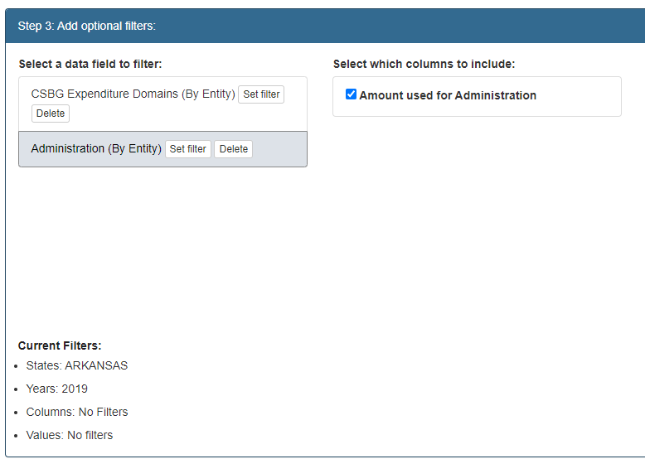
Step 4:  In the selection box for which columns to include, deselect all columns except for “Total.” | 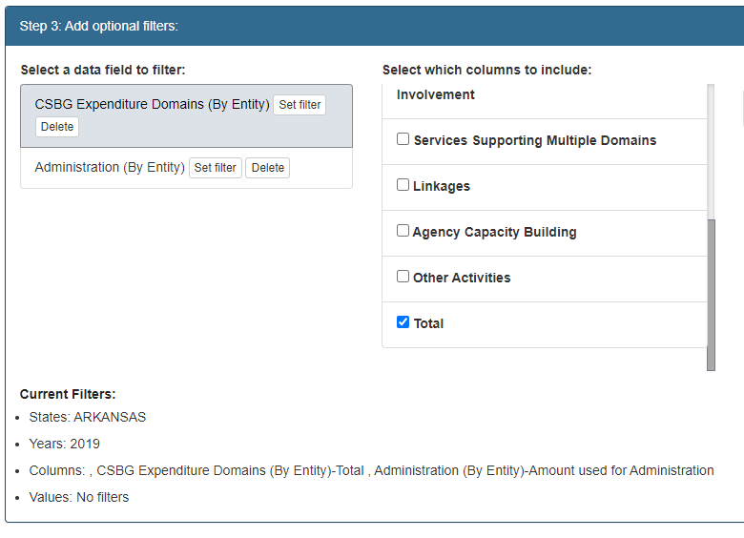
Step 5:  In the fourth section, select “Bar graph” to create a visualization of the proportion of administrative costs to total expenditures.  Leave the title of the report the same and select “Create Data Report.” | 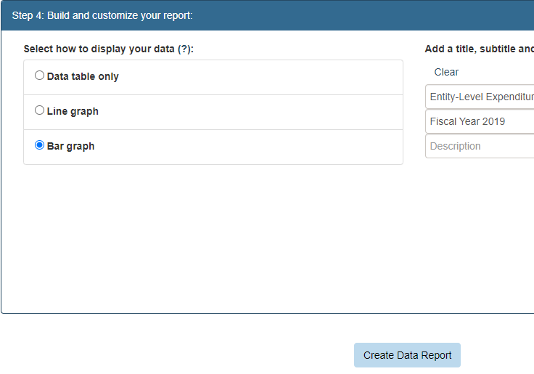
Step 6:  The bar graph has been generated, but an outlier case is making the bar graph unreadable.  Select “Customize report” to remedy this problem. | 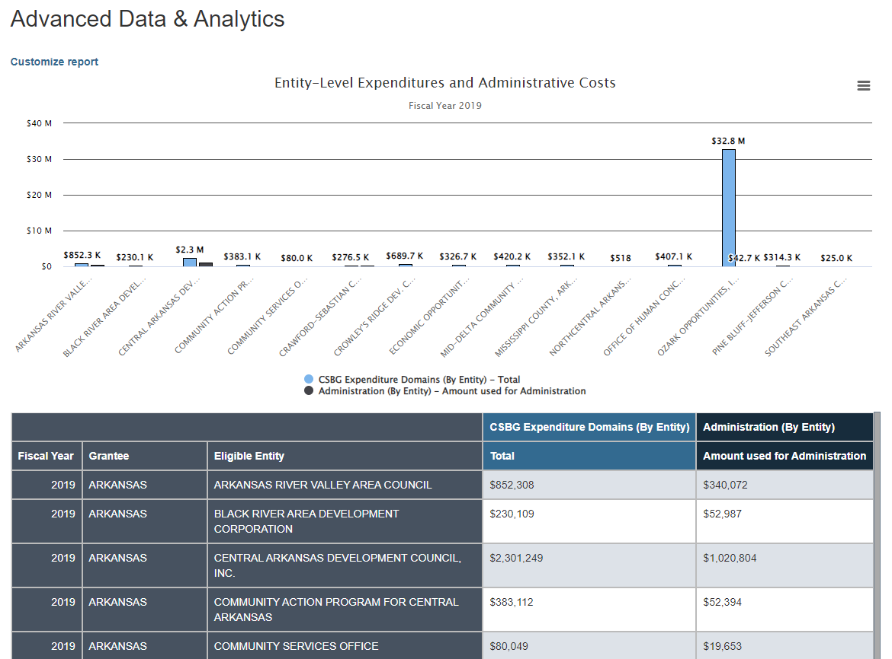
Step 7:  In the third section, under the “Filter by value:” menu, create a filter on the “Total” column.  First, select “Less than” from the drop-down menu next to “Value is,” then type 32000000 in the box below.  This will remove the outlier entity. | 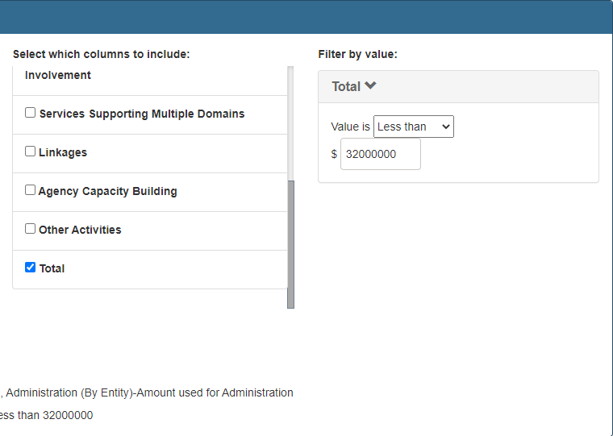
Step 8:

Leave everything in the fourth section the same and select “Create Data Report.”
Step 9:  You are done! | 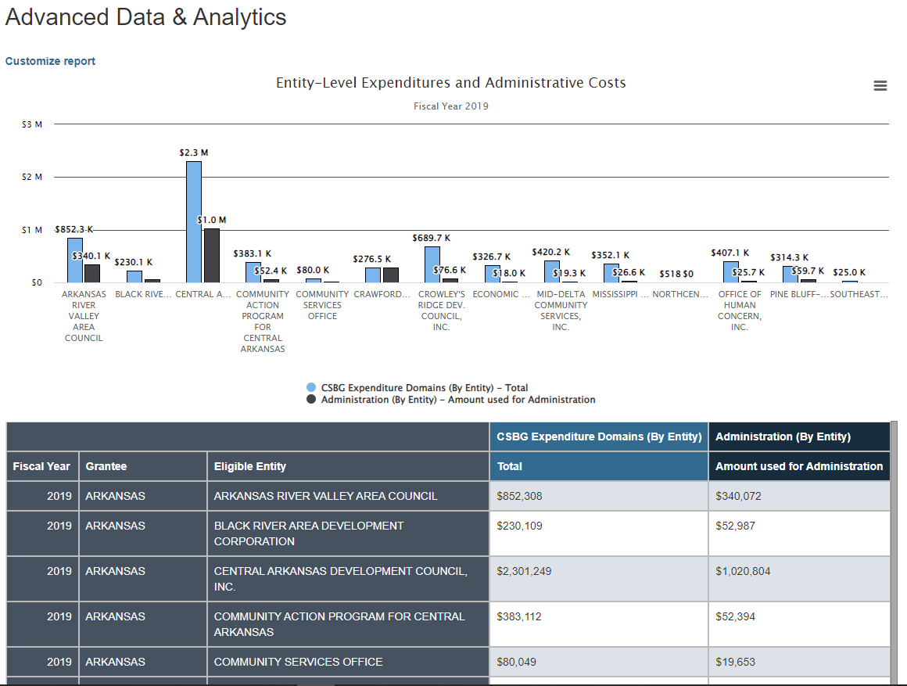

Practice Exercise #3
PRACTICE EXERCISE #3 SOLUTION (USING WISCONSIN)

Agency administrators and legislators in your state want to make sure that CSBG entities are reaching households at the very lowest income levels. You’d like to produce a FY 2019 report that shows the portion of all households assisted by CSBG entities in your state who were in the lowest income group (at or below 100% FPL). How would you use the Advanced Data and Analytics tool to do this?
Step 1:

Once in the Data Warehouse, select the Advanced Data and Analytics option.
Step 2:  In the Advanced Data and Analytics screen, select “2019” (since we are only interested in data from that year).  Then select “State Data” under “Select geographic level of data” and select your state. (Wisconsin is used as an example for this exercise). | 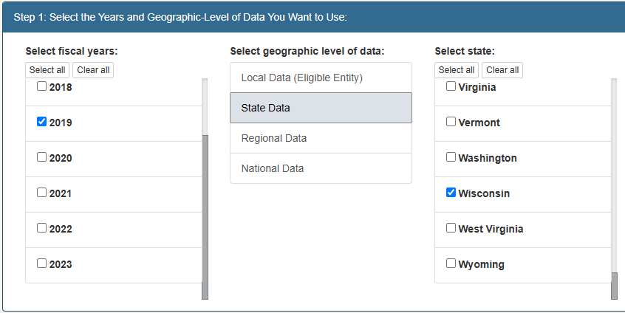
Step 3:  In Step 2, select “All Characteristics Report (Module 4) - State,” with “Household Level Characteristics” as the sub-topic.  Scroll down in the data field menu and select “Level of Household Income (%) of HHS Guideline) (Statewide Total).” | 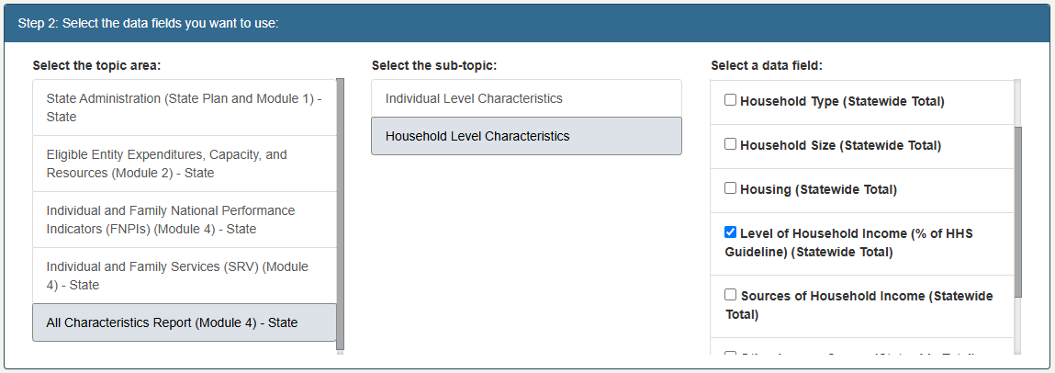
Step 4:  In Step 3, select the first three columns in the selection box “Select which columns to include” (“Up to 50%”, “51% to 75%”, and “76% to 100%”) as well as “Total.” | 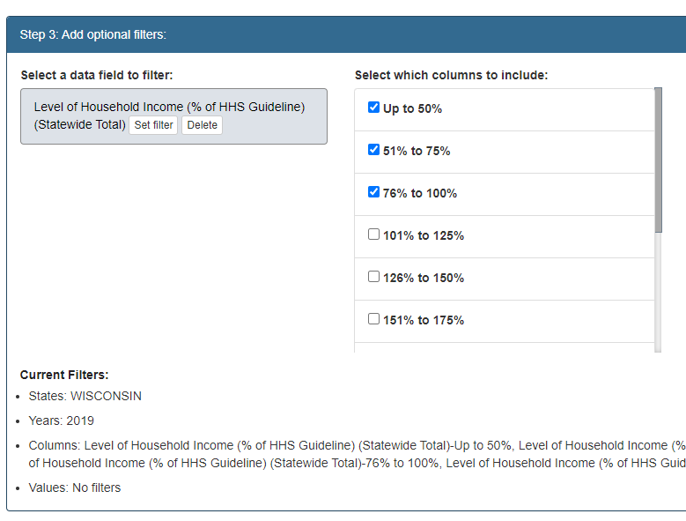
Step 5:  In Step 4, select “Bar graph” to provide a visualization of the proportion of households below 100% FPL. | 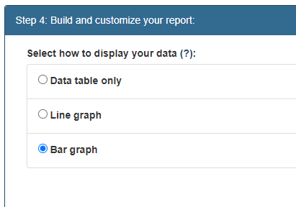
Step 6:  Name the graph “Households Served Below 100% FPL” with the subtitle “Fiscal Year 2019.”  Select “Create Data Report.” | 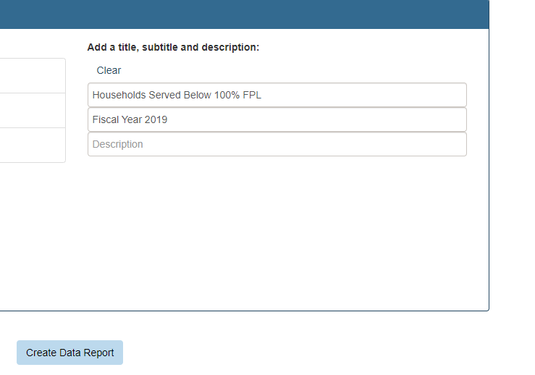
Step 7:  You are done! | 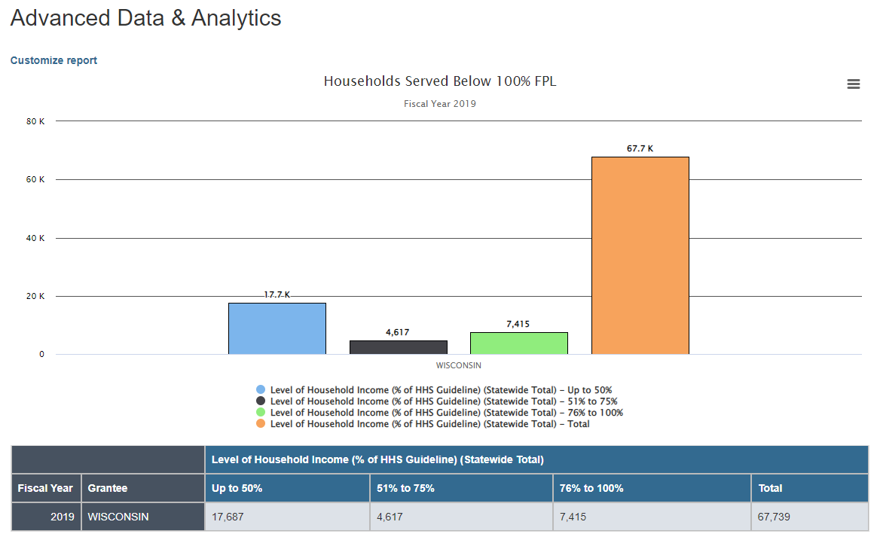

Practice Exercise #3B
PRACTICE EXERCISE #3B SOLUTION

You decide to further explore how the proportion of lowest income households assisted by CSBG entities in your state has shifted over time. How would you use the Customize Report option at the top of the report screen to add FY 2018 data to the existing graph/table?
Step 1:

Starting on the results page from the previous example, click “Customize report” at the top of the page.
Step 2:  Select “2018” from the fiscal year menu.  Leave all other selections in the first section the same. | 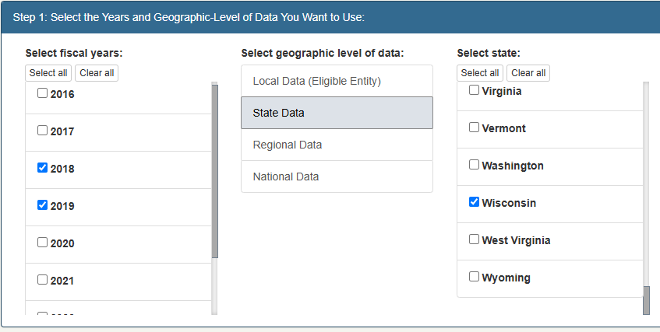

Step 3:  We do not need to make any changes to Step 2 or Step 3. | 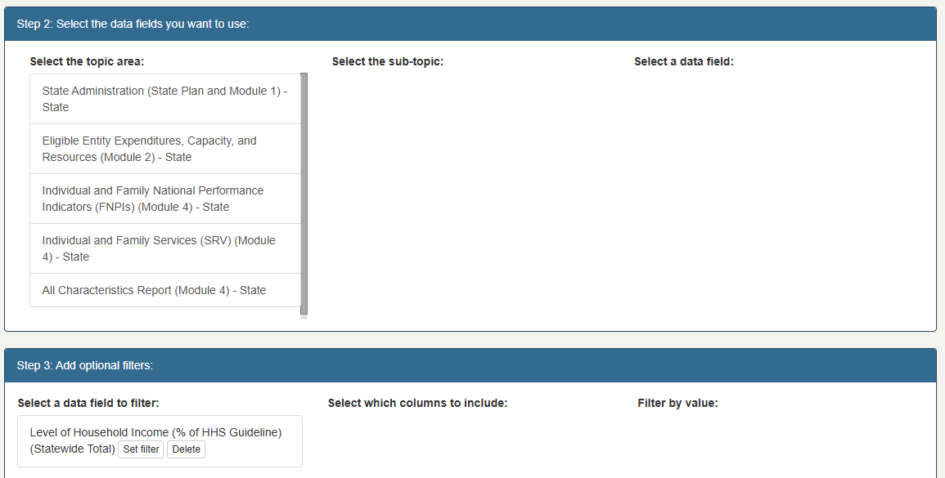
Step 4:  In the fourth section, rename the subtitle to reflect the additional year: “Fiscal Year 2018 and 2019.”  Select “Create Data Report.” | 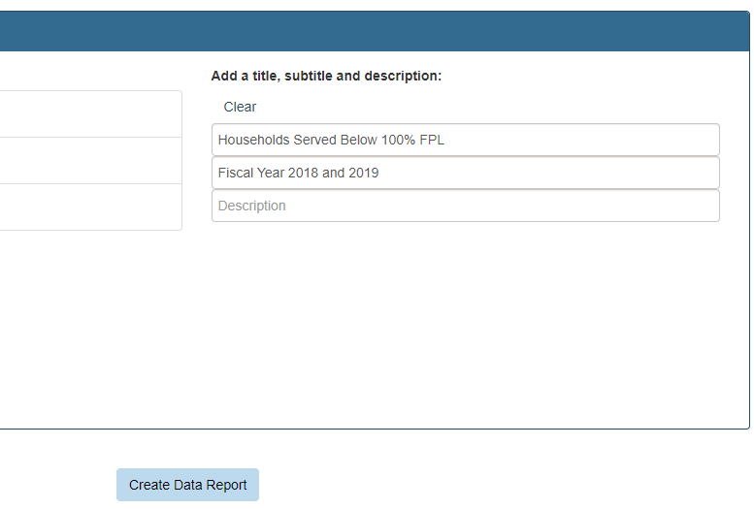
Step 5:  You are done! | 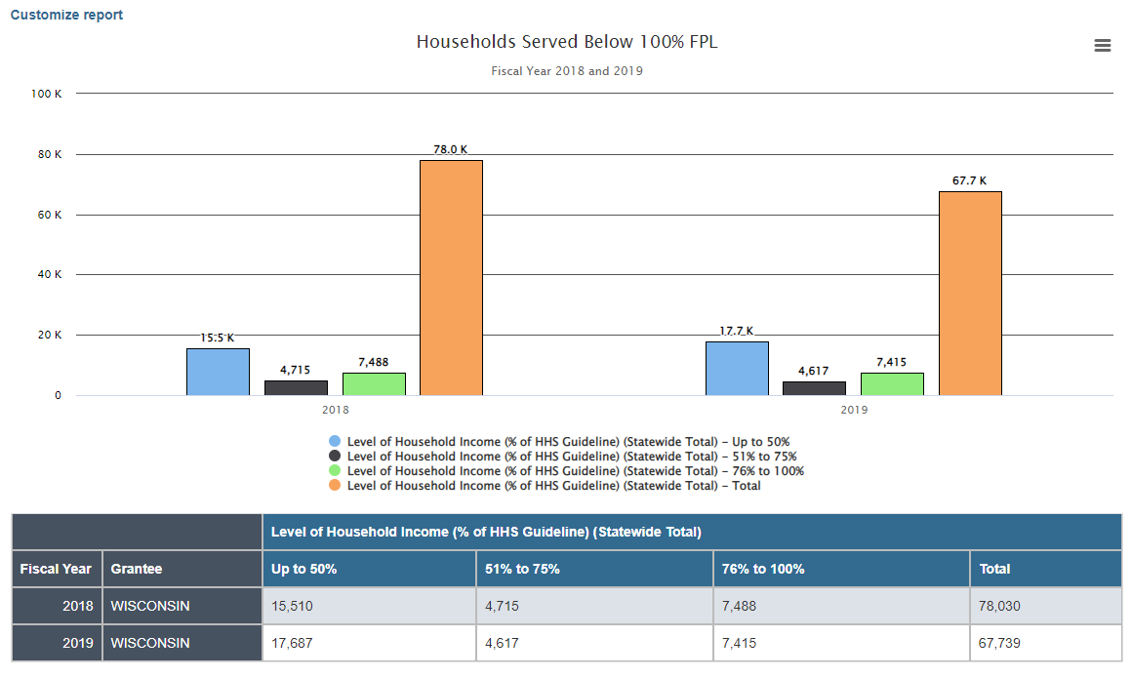

Practice Exercise #3 – Deeper Dive
PRACTICE EXERCISE DEEPER DIVE SOLUTION

During and after COVID, many legislators have asked if there has been an increase of households at “higher” income levels receiving services. Can you use the report(s) you produced above to answer this question? If not, how would you modify the existing tables/graphs to also display higher income groups?

Step 1:

Starting on the results page from the previous example, click “Customize report” at the top of the page.
Step 2:  Leave the first and second sections as they are. | 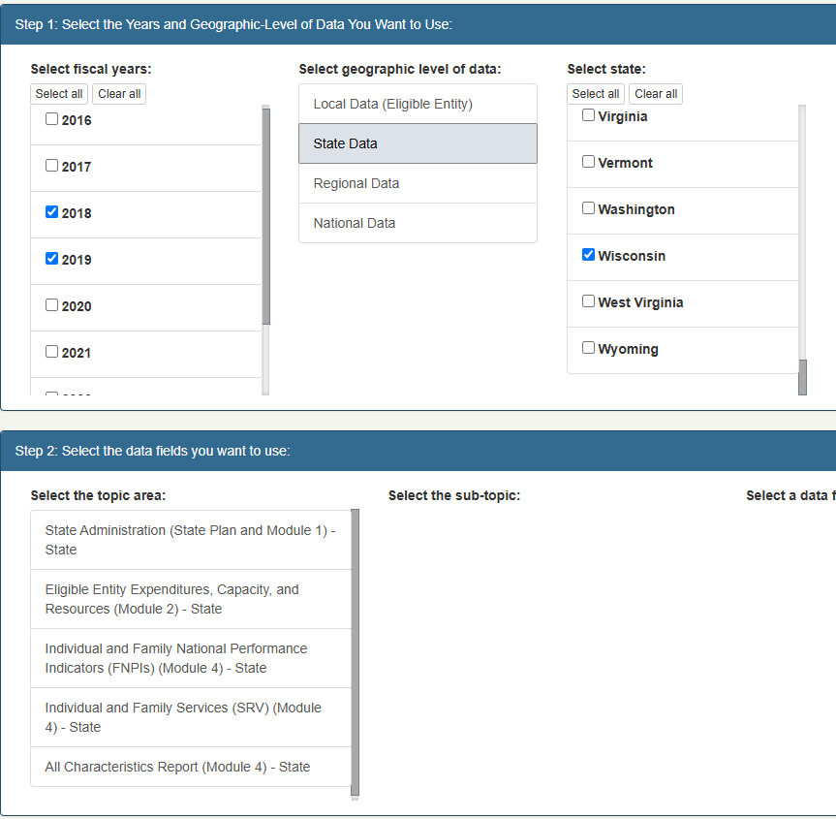
Step 3:  In the third section, add the top three data columns (“176%-200%”, “201% to 250%”, and “251% and Over”). | 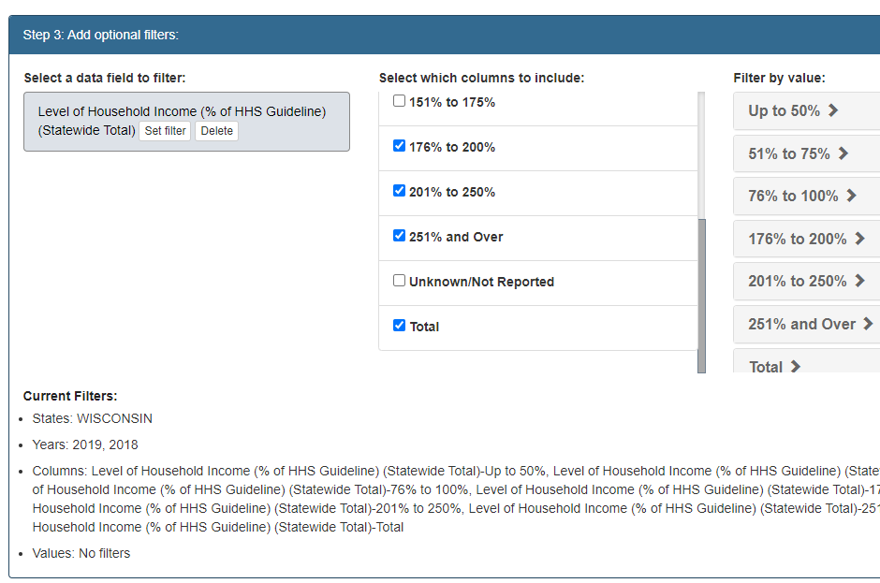
Step 4:  In the fourth section, change the display from “Bar graph” to “Line graph” to better see the increase or decrease for each group from year to year. | 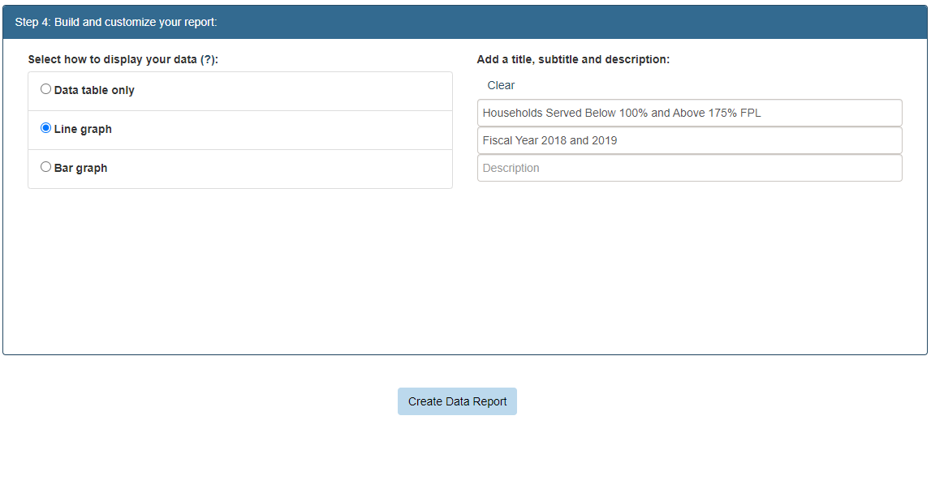
Step 5:

In the fourth section, rename the report to “Households Served Below 100% and Above 175% FPL.”

Select “Create Data Report.”
Step 6:  You are done!  Note- to remove the “Total” line from the graph, you can select “Level of Household Income (% of HHS Guideline) Statewide Total | 